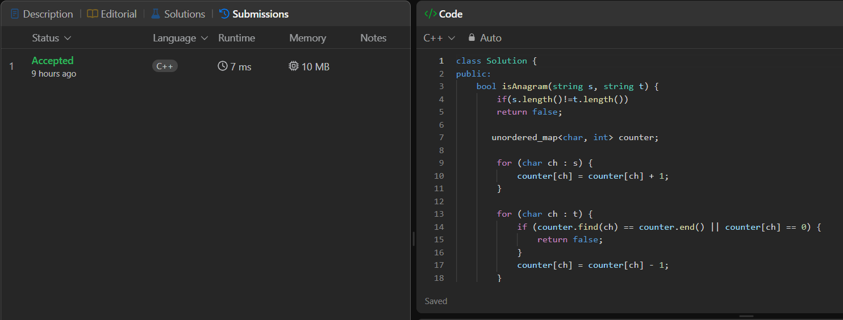

class Solution {
public:
bool isAnagram(string s, string t) {
if(s.length()!=t.length())
return false;
unordered_map<char, int> counter;
for (char ch : s) {
counter[ch] = counter[ch] + 1;
}
for (char ch : t) {
if (counter.find(ch) == counter.end() || counter[ch] == 0) {
return false;
}
counter[ch] = counter[ch] - 1;
}

return true;

}
};

